EBU6304 Software Engineering Group Project

2025-26
Group number | 101
member 1 | QM no: 231223782 | Name: Chenyou Xu
member 2 | QM no: 231223748 | Name: Meiyu Fu
member 3 | QM no: 231224044 | Name: Lingyue Yang
member 4 | QM no: 231223793 | Name: Leyan Li
member 5 | QM no: 231223519 | Name: Shiqi Xu
member 6 | QM no: 231224033 | Name: Yuehan Meng

First report

Requirements
This section outlines the foundational methodologies employed to define and manage the project's scope, ensuring a structured approach to development. It details the fact-finding techniques used to gather requirements, the iteration plan for incremental delivery, and the specific prioritization and estimation methods applied to balance resources with project goals.
1.1 Fact-Finding Techniques
To identify the requirements of the system, our group used three main fact-finding techniques: document analysis, group discussion, and simple interview-style questioning. Although the project brief provided the general scenario and suggested system functions, more detailed user needs still had to be identified. Therefore, we analysed the recruitment process from the perspectives of different stakeholders and used the findings to support the backlog and prototype design.
First, we used document analysis to examine the project brief. This helped us identify the current recruitment workflow, the main stakeholder groups, and the initial system scope. From the brief, we identified three main user roles: TA applicants, Module Organisers (MO), and administrators. We also noted that the current process relies on forms and Excel files, which suggests a need for a clearer and more efficient workflow. In addition, we briefly looked at similar TA recruitment practices in universities to understand common workflow structures. For example, XJTLU’s Teaching Assistant Management System suggests that a dedicated platform with clear user roles and structured recruitment stages can be useful in a similar educational context.
Second, we used group discussion to explore the likely needs, tasks, and pain points of different stakeholders. By comparing the expectations of TA applicants, Module Organisers, and administrators, we moved from the high-level description in the brief to a more detailed set of initial requirements. This also helped us define a realistic scope for the first prototype rather than attempting to include every possible feature at once. Our discussion suggested that TA applicants mainly need functions such as viewing job information, creating a profile, uploading a CV, submitting applications, and checking application status. It also highlighted the need for Module Organisers to post vacancies, review applicants, and update recruitment decisions, as well as the need for administrators to monitor TA allocation and workload across the system.
Third, we used simple interview-style questions to examine user needs in a more practical way. These questions focused on issues such as what information should appear in a job post, what information applicants should provide, what makes the current spreadsheet-based process inconvenient, and whether users would benefit from status tracking and clearer recruitment stages. This technique was especially useful for refining the TA-side workflow in the first prototype, while still keeping the wider needs of MO and Admin users in the backlog for later iterations.
Overall, these techniques helped the team identify initial requirements, clarify the project scope, and determine which functions should be prioritised in the first prototype. Since the first iteration could not cover every feature in equal depth, the prototype focused mainly on the TA-side workflow, while the needs of Module Organisers and administrators were retained in the wider backlog for later development. The detailed question lists and interview notes are included in the supporting materials as evidence for this stage of the requirement analysis.

1.2 Prioritisation Method
To deliver a minimum viable product (MVP) with basic functions within the limited project time frame, our team adopted the MoSCoW (Must Have, Should Have, Can Have) priority sorting technique. This framework enables us to distinguish between key functional requirements and supplementary improvements, thereby ensuring that the core recruitment process is not disrupted.
lMust Have : We classify core functions as non-negotiable requirements. These include the Data Storage (US-D01) and Concurrent File Writing Handle (US-D03) at the system foundation level, which form the pillars of the system. Given the "no database" limitation of the project, User Account Management (Registration, Login, Password Recovery) (US-A06) and Role Permission Control (US-D02) are also prioritized to ensure data integrity and system security. Without these, the system would not be able to provide a secure or usable environment for TA applications.
lShould Have : The functions in this category can significantly increase value but are not essential for the initial "go live". For example, View Overall TA Workload(US-A01) and Main Workflow Test (US-T01) can improve management efficiency and system robustness. Although these functions are the targets of the initial release, they can be postponed temporarily if the key "must have" tasks encounter technical obstacles.
lCould Have : These are "nice-to-have" functions that can enhance user experience or management convenience, such as Application History Archive (US-C02) or Export Final Allocation Reports (US-A05). These tasks will only be addressed after all higher-priority tasks are stable.
By applying this method, we strive to ensure that the highest commercial value is delivered first.
1.3 Estimation Methods
Our team utilised Story Points based on the Planning Poker method to estimate the relative effort, complexity, and inherent risk of each User Story. Unlike traditional time-based estimation, Story Points allow the team to focus on the "size" of a task independent of individual developer speed, fostering a more accurate consensus on workload.
Complexity Weighting: We adopted a Fibonacci sequence (1, 2, 3, 5, 8) to reflect the increasing uncertainty of larger tasks. Medium-complexity stories involving form validation or multi-file data linking were typically rated 3-5 points.
Baseline Calibration: We established a reference point where simple, well-defined tasks—such as View Available Jobs (US-TA03)—were assigned 1-2 points. These tasks involve minimal logic and no external dependencies.
High-Complexity Challenges (8+ points): In our specific "no-database" context, tasks such as US-D02: implementing a central authentication check or US-D03: resolving concurrent file-writing conflicts were assigned 8 points. These estimations reflect the high technical risk and the intensive logic required to manually handle data consistency without a Database Management System.
1.4 Iteration Plan
The project is structured into four iterations, following an incremental delivery logic from "foundational architecture" to "advanced intelligence." Our planning process strictly incorporated the Priority and Estimation of each user story to ensure a balanced development pace and efficient resource allocation:
- Iteration 1 (Mar 23 - Mar 30): Focused on constructing the underlying framework. Key tasks include implementing the file-based persistence system (as per project requirements), designing multi-role authentication, and developing basic profile/job viewing features to verify the storage architecture.
- Iteration 2 (Mar 31 - Apr 12): Aimed at establishing the core business workflow. This involves a complete loop where MOs post job requirements and review applicants, while TAs can upload CVs, submit applications, and track their progress.
- Iteration 3 (Apr 13 - Apr 28): Centered on administrative management and data analytics. Features include centralized supervision of TA workloads, global job listings, and account information for Administrators, alongside integrated statistical tracking for MOs.
- Iteration 4 (Apr 29 - May 10): Serves as the technical enhancement phase. This iteration delivers advanced features, including an AI-assisted recommendation system for workload evaluation, a file-locking mechanism for data integrity, and comprehensive system testing.
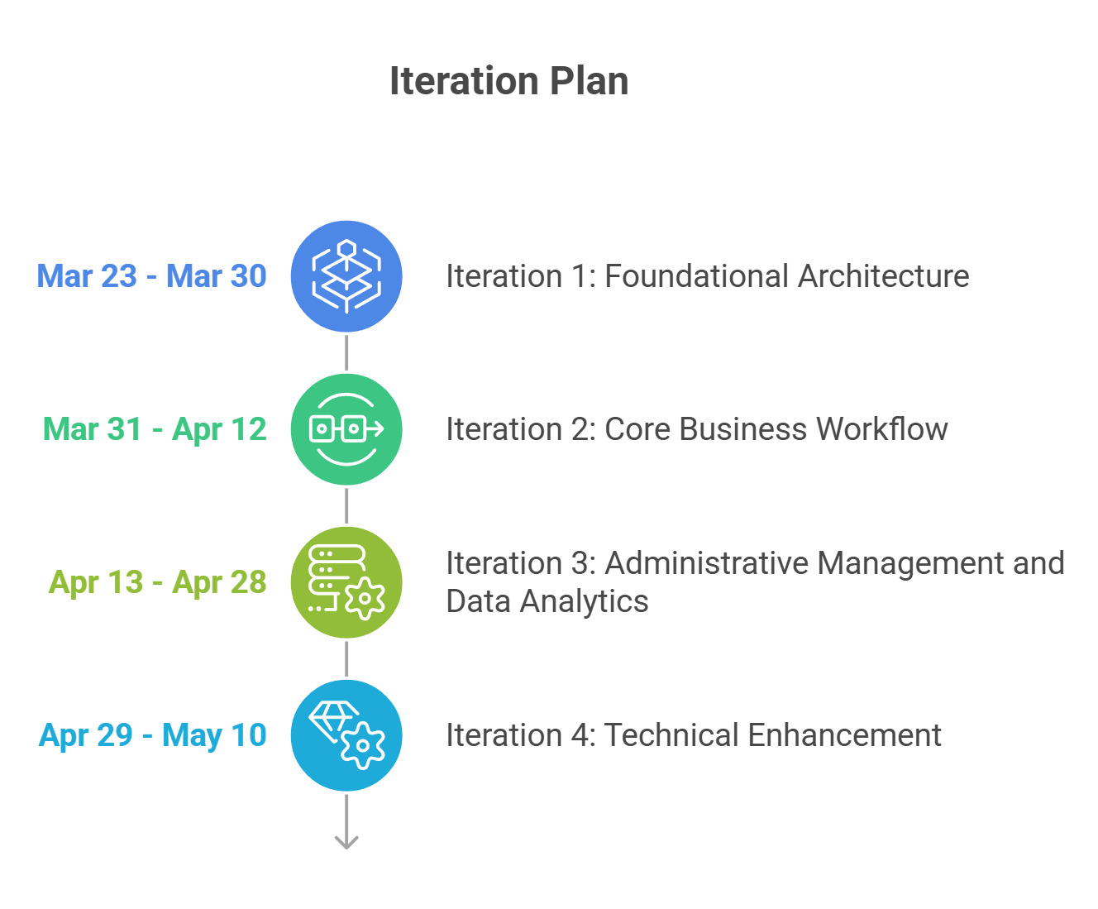
Figure 1.Iteration Plan
This phased approach ensures the delivery of a functional incremental version at each stage. It aligns with the Agile principle of "prioritizing core functionality before technical optimization," effectively mitigating development risks while ensuring system robustness.

Supporting material
This section presents the findings from stakeholder interviews conducted to define the core requirements for the TA Recruitment System. The insights from both a Module Organiser and an applicant highlight current pain points and the functional features needed for a more efficient workflow.
2.1 Interview Notes for a Module Organiser
Q: What information should be included when posting a TA job?
A: The job post should provide enough detail for students to decide whether they are suitable for the role. At minimum, it should include the module name, module code, the main duties of the TA, the required skills, and any restrictions such as programme or year of study. It would also be helpful to include practical details such as the working period, the number of vacancies, and the application deadline. Clear job information is important because it helps reduce confusion and can also improve the quality of applications.
Q: Would you want to edit a job after it has been published?
A: Yes, this would be necessary. In practice, some details may change after a job is published, for example the timetable, the duties, or the closing date. If the system does not allow editing, the organiser may have to create a new post or communicate changes in an unclear way. Being able to update an existing post would make the process more flexible and help keep the information accurate for applicants.
Q: What student information would you like to see when reviewing applicants?
A: I would want to see the main information that helps me decide whether a student matches the role. This would include the applicant’s name, student ID, programme, year of study, and perhaps a short summary of relevant experience or skills. It would also be useful to see when the application was submitted and whether the applicant meets the main eligibility requirements. Having this information displayed clearly would make it easier to compare applicants.
Q: Do you think viewing a student’s CV is necessary?
A: Yes, I think it is important. Basic student information is useful, but it is usually not enough to make a decision. A CV gives more complete background about the student, such as their academic experience, technical skills, teaching-related experience, or other relevant activities. This helps the Module Organiser form a better judgement about whether the applicant is suitable for the TA position.
Q: What is inconvenient about using forms or Excel files for TA recruitment?
A: The main problem is that the information is not managed in one organised place. When using forms or Excel files, it can be harder to track who has applied, which applications have already been checked, and what decision has been made for each student. It may also take more time to search for specific information or compare applicants. If there are many applications, the process can easily become confusing and inefficient.
Q: Would it be useful to mark applicants with different statuses in the system?
A: Yes, this would be very useful. Different statuses, such as under review, shortlisted, accepted, or rejected, would make the process much easier to manage. They would help the organiser keep track of progress and avoid confusion, especially when dealing with a large number of applicants. A status system would also make the recruitment workflow more structured and transparent.
Q: What would make the selection process easier for a Module Organiser?
A: The process would be easier if all key tasks could be completed in one place. For example, the system should allow the organiser to post jobs, check applicant details, open CVs, compare candidates, and update decisions without switching between different tools. It would also help if applicants could be filtered or sorted by useful criteria, such as programme, year of study, or application status. This would save time and make the selection process more efficient.
Q: How should the system show that a vacancy has been filled?
A: The system should clearly update the job status once a suitable TA has been selected. For example, the vacancy could be marked as filled or closed so that it is obvious that recruitment has been completed. This would help the organiser keep track of outcomes and prevent unnecessary further applications. It would also make the status of each post easier to understand at a glance.
Q: Do you have any other suggestions for the system besides the functions mentioned above?
A: From a practical point of view, I think one important function is real-time updates on how many students have applied, how many have already been confirmed, and how many vacancies are still available.
2.2 Interview Notes for a TA Applicant
Q: Have you applied for a TA job before?
A: Not really. I looked at some before, but I did not actually apply.
Q: Why not?
A: I was not very sure about the process. Sometimes the information was too brief, so I was not sure whether I was suitable.
Q: What do you usually want to see in a TA job post?
A: The module name first. Then what the TA is expected to do.
Q: Anything else?
A: Yes, probably the time commitment. Also whether they want someone who has already taken the module.
Q: Would you mind creating a profile in the system?
A: No, that is fine.
Q: What should be included in the profile?
A: Basic details, like name, student ID, programme, email, year of study. Maybe some skills as well. If there is a section for previous experience, that would be useful.
Q: Do you think uploading a CV is necessary?
A: Yes.
Q: Why?
A: It is easier. A lot of things are already in the CV, so I would rather upload it than type everything again.
Q: What is annoying about using forms or Excel files?
A: It is easy to lose track of things.
Q: In what way?
A: You may not know whether the application was received. Also, if you apply for more than one role, you may have to fill in similar information again.
Q: Would you like to apply for several TA jobs in one system?
A: Yes, definitely. That would save time.
Q: After applying, what kind of feedback would you expect?
A: First, a confirmation that the application was submitted. After that, I would like to know whether it is under review or if there is already a result.
Q: Do you need a lot of updates?
A: Not a lot. Just enough to know what is happening.
Q: What would make the whole process better?
A: A simple interface. Clear job information. Easy CV upload. And a page to check application status.

